Video Game Vision Document: (PLACEHOLDER NAME)

Jaafar Kaoussarani

William Xie

Marianick Benoit

* Introduction

Video game programmed using the LOVE2D API with the Lua coding language. Event-based programming with elements of object-oriented. The game itself will be a puzzle platformer. A hub area will give access to the many different levels of the game. Each room will contain a clue, all of which can be combined in the hub area. This forms a lead, which both progresses the story and gives the player access to more levels.

* Opening the game and menu

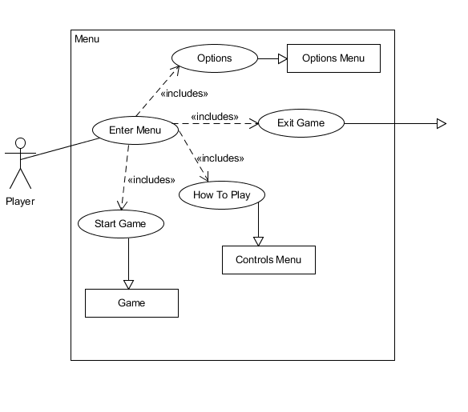As soon as the game opens, the team name will display, followed by a menu. This menu MUST contain a Start button and an Exit button. How to Play and Options menu preferable but can be omitted if time is lacking. Once an optional button is pressed, it will display a new menu, either replacing the previous menu or displaying it on top of the previous menu.

2.1) Options Menu

Current options menu would be very simple. Simple volume controls for now. Resolution options and others may be included if time permits.

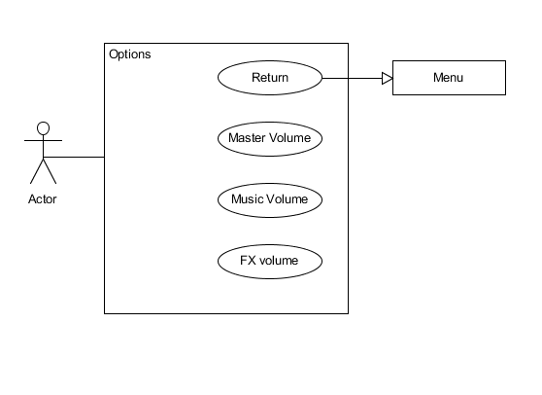

2.2) How to Play Menu

Simply displays basic controls. Will not be changeable.

* Platforms

The hackathon demo will be developed using the Windows 10 platform, and the aim is to have the demo work on most modern Windows systems. Eventually, the final game should work on Windows, OSX, and Linux, but the last two can always be incorporated later. Mobile is an option for after release.